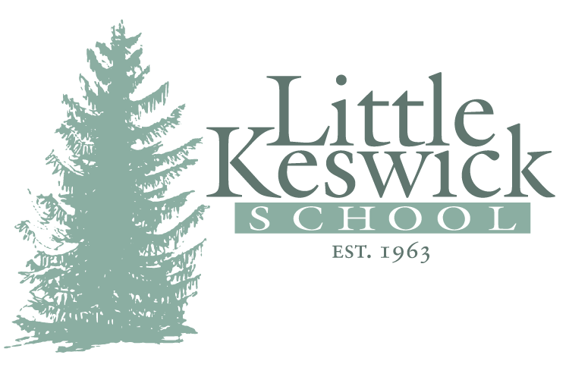

Little Keswick School—Assistant Admissions Director
About the School: Little Keswick School is a non-profit, special education therapeutic boarding school located outside of Charlottesville, Virginia with a rich history and a national and international reputation of excellence. For 54 years the school has provided individualized support for the academic, social and emotional growth of each student. Our small school provides nurturing relationships, intensive clinical interventions and an individualized education for 35 boys in our highly structured and safe environment. LKS accepts boys ages 9-15 at the time of enrollment from throughout the country and abroad who have a complex set of challenges and low average to superior intelligence.
Opportunity: Little Keswick School seeks an Assistant Admissions Director to join the admissions team who will report to the Director of Admissions and be responsible for the development, leadership and management of all admission and marketing functions at the school.

A successful candidate will:
- Have experience working with adolescent students with social, emotional, behavioral and learning needs
- Have adequate child development and psychological background to read and interpret psycho-educational
and neuropsychological testing
- Have comprehensive special education and/or clinical knowledge to assess student complexity and fit
- Have exceptional verbal, written and organizational skills
- Have excellent phone skills and demeanor
- Be able to listen to a client’s needs and respond appropriately
- Have strong interpersonal skills with students and coworkers
- Be able to learn the LKS program and explain the school effectively to parents and professionals
- Have proficient technology skills including database management, social media marketing and website development
- Be organized and able to multi-task
- Be able to attend professional conferences
- Be able to assist with event planning and services
- Must possess initiative and judgment capabilities to support admissions, marketing, and student referrals

Key personality traits:
- Have an engaging personality to provide campus tours and be the face of LKS at professional conferences
- Be independent, flexible and able to take initiative
- Enjoy meeting families, referring professionals and building relationships
- Understand and navigate complex family dynamics
- Have a passion for helping people and providing services to others
- Be able to understand and implement student behavioral support
Education/Experience: A degree in special education or psychology is required and an advanced degree preferred; two or more years working in a therapeutic boarding school or residential program or other education related setting; prior work experience in admissions or as a clinical professional preferred.
Benefits: Competitive salary commensurate with experience; Benefits include: Medical, dental, life insurance, tuition assistance; Profit sharing plan and 401K.
Application: Please send resume, cover letter, and at least 3 professional references to: childebrand@littlekeswickschool.net

Hiring Date: Accepting applications through fall of 2017 with an anticipated start date of January 1, 2018 or sooner.

Contact: Marc Columbus, MEd, Headmaster, 434-295-0457, www.littlekeswickschool.net

